Faraday’s Law

Name:_Tyler Gillette______________________________ Date: 4/14/20____

**Credits:** Original Author: Jeff Drach, York Community High School. Adaptation by Roger Key, John Walkup, California State University, Fresno Physics Dept.

**Introduction**:

Michael Faraday was an English scientist that greatly contributed to the study of electromagnetism including building one of the first electric motors. He also contributed to how induction occurs. In this simulation, we will be experimenting with the process of induction.

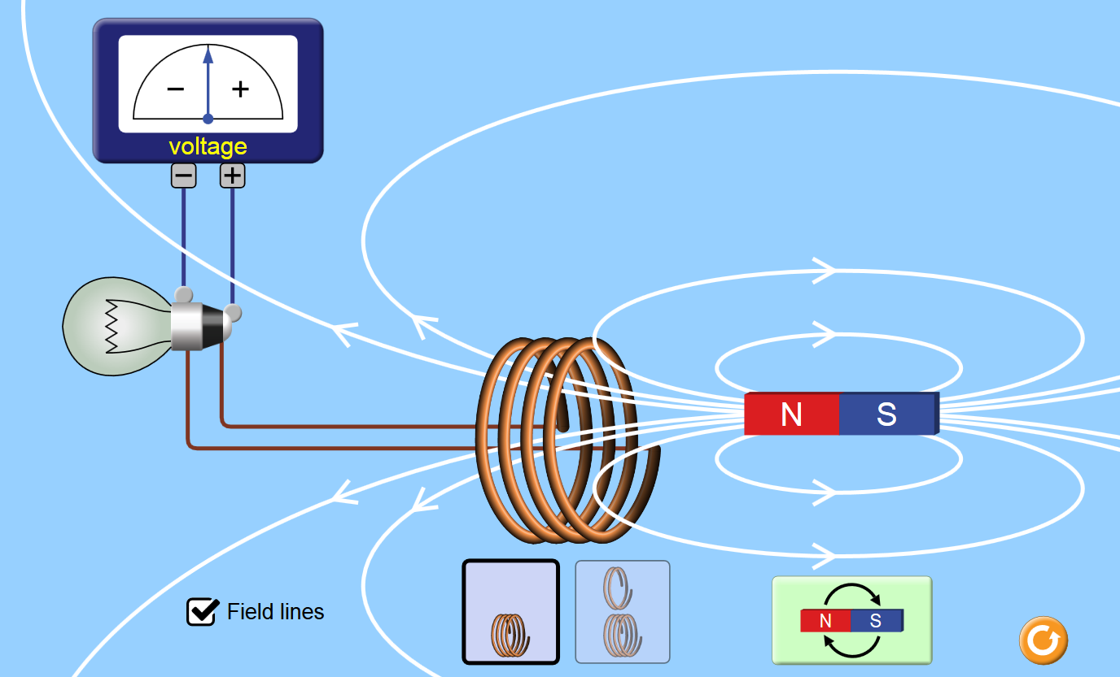

Total points for this activity = 35.

Background material:

AC or DC? <https://youtu.be/xyQfrzBfnDU>

Power generation: <https://youtu.be/AHFZVn38dTM>

**Link to Simulation:**

<https://phet.colorado.edu/sims/html/faradays-law/latest/faradays-law_en.html>

Turn on “Field Lines”

Use this document to record your answers, then upload it to Canvas.

Things to try and notice: (be ***specific*** in your answers for example, when the needle moves on the meter, is it + or -? Is it strong or weak? Does the light glow? Bright or dim?)

1. Start the initial position of the bar magnet to the right of the coil. Which direction does the flux point in the interior region of the coil? 1 pt.

To the left because the north side of the magnet is on the right side of the coil. This means that the magnetic field will point to the left.

1. Move the bar magnet toward the left, that is, toward the coil.  During this motion, what happens to the flux?  Why? 2 pts.

The flux increases because the magnetic strength is stronger the closer the coils are to the coil.

1. Which direction does the change in flux point?  Explain. 1 pt.

To the left, because the magnetic force points from the north end to the south.

1. If you were behind the magnet, watching it move away from you and toward the coil, in which direction would the current in the coil travel? (Clockwise or counterclockwise?)  Explain. 2 pt.

Counterclockwise, this is due to the right-hand rule you place your thumb on the induced current direction and curl your fingers.

1. During the above motion, where is the change in flux highest?  When the bar magnet is far from the coil or where it begins to penetrate the coil?  Explain in terms of the B-field lines penetrating the coil's interior region. 1 pt.

When it begins to penetrate the coil. That’s when the greatest change in magnetic field happens. The B field lines get tighter the closer the magnet gets to the inside of the coil.

1. Does the direction of the current illustrated by the voltmeter correspond to your questions above?  Explain. 2 pt.

Yes, the current flow was counterclockwise, and the voltmeter shows that its negative.

1. What happens if you move the magnet into the coil very slowly vs. very quickly. What relationship can you make between the motion of the magnet and the current produced? [hint: think about change in flux] 1 pt.

A little bit of current is generated vs a lot of current. This can be seen from the faraday equation B/change.

The less time the larger the field.

1. Can you produce a current when the magnet goes up and down when centered in the loops? Explain. 2 pt.

No, the mass is parallel to the magnetic force. No current is generated.

1. Next try two loops vs. four loops of wire. What relationship can you make between the number of loops and the current produced. 1 pt.

Half the amount of current is generated

1. Try putting the magnet in the center of the loops and click the magnet flip button. What happens as you spin the magnet several times? 1 pt.

The B changes quickly producing a lot of

1. Look at the Voltage needle as you spin it multiple times. What type of current do you think it is producing? AC or DC? 1 pt.

Alternating current. The current spikes from negative to positive and back as you flip the magnet and change the B.

1. Free response: In paragraph form, describe what happens as the magnet passes through the middle of the coil and continues its motion toward the region to the left of the coil. (Walk back through the process illustrated in your responses to Questions 1-6,) 5 pts.

As the magnet passes through the middle of the coil the flux direction changes the current is going to change directions quickly. As the north end of the magnet goes through the coil the current will begin to flow counterclockwise and as the middle of the magnet passes through the coil the current will change directions and flow clockwise.

1. Until very recently, large scale electricity storage was not possible. Do some research online and write a paragraph or two describing three methods of possible large-scale electricity storage and make an argument for the one you think will be viable for us in Central California. 10 pts.

There are many ways we can store electricity, we can store it in batteries, hydroelectricity or thermal energy storage.

Batteries use chemicals that slowly breakdown to store electricity, there could be issues in a lifetime of the chemicals used and the physical footprint of the battery. hydroelectricity would pump water up a mountain or incline and then letting it flow back down using some method to retrieve that energy like a waterwheel you could gain the electricity back. Storing it at the top of the incline can lose some water to dissipation or have issues in hardware. The last was thermal energy which you could use to heat an object or liquid up and later use the object to help heat/cool other objects, but the issue with this method is that its short-term solution.  I believe that batteries are a great way for us to store electricity because the breakdown in the chemicals are slow. Batteries usually have a shelf like of 8–10 years vs how long the pump equipment would last. Hydroelectricity would be a better long-term solution, but we are lacking water in California thus I believe that battery storage would be a better alternative here.

Go to Prowritingaid.com and set up an account if you don’t already have one. Use the free trial. Copy the writing you do for this question and paste it into prowritingaid.com (Use App).

Click on any of the buttons and take a screen capture of the window. (The text portion is all that's necessary).

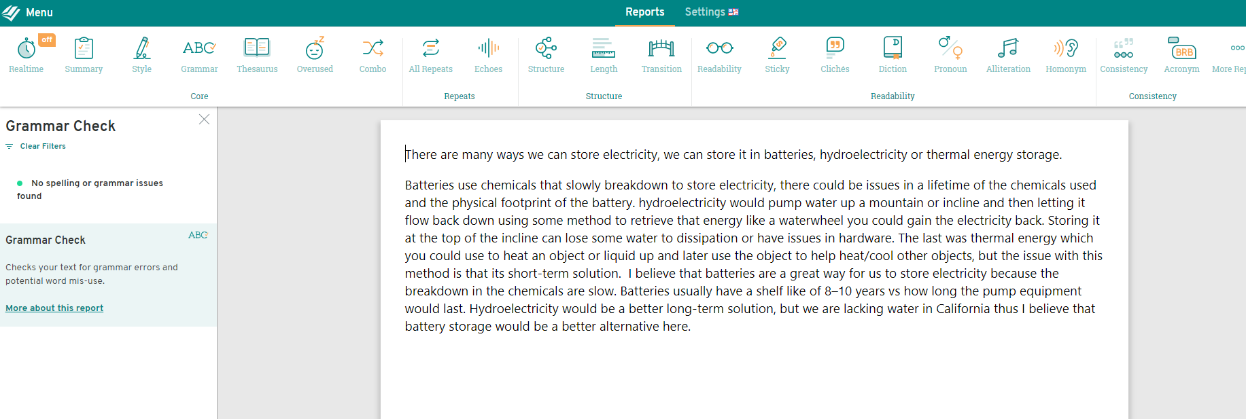

Select the button *Summary*.

Take a screen capture of the Summary page.



Go through the buttons (e.g., Structure, Length, Grammar) and act on some of its suggestions. Make enough changes to generate a significant improvement in your sample. (You don't have to stamp out all the problems it identifies.)

Take a new screen capture of the Summary page.



1. Challenge: Open the page at <http://student.pasco.com/epub/Physics/eBook-SB/BookInd-1665.html> and do **part one** of the activity there. Take a screen capture with your highest rpm and include it in this report. 5 pts.

[Student Access Code: NGSS58653-EP3-SB-0720-M5UJJ, then click Investigations and go to 19B: Electric Motor]

4a. when you change the polarity of the magnet halfway through a revolution, the rotator slows down to draw the previous magnet closer.

4b. it pushes the rotator away. This increases the speed of the rotations.

4c. the ideal time to change the polarity is right when the magnet in the rotator passes over the electromagnet.

4d. Angular velocity = 4.98 rpm, Maximum Angular velocity = 29.77 rpm, average angular velocity = 14.31 rpm.

One is the current value of angular velocity; one is the fastest value it reached and the other is the average over a 60 second time period.

4e. I was able to spin in faster when it was weaker because I was not able to flip the polarity fast enough to increase the speed past a certain point when the magnet was stronger. Diminishing returns the stronger the magnet was based on my reflexes and hardware inputs.

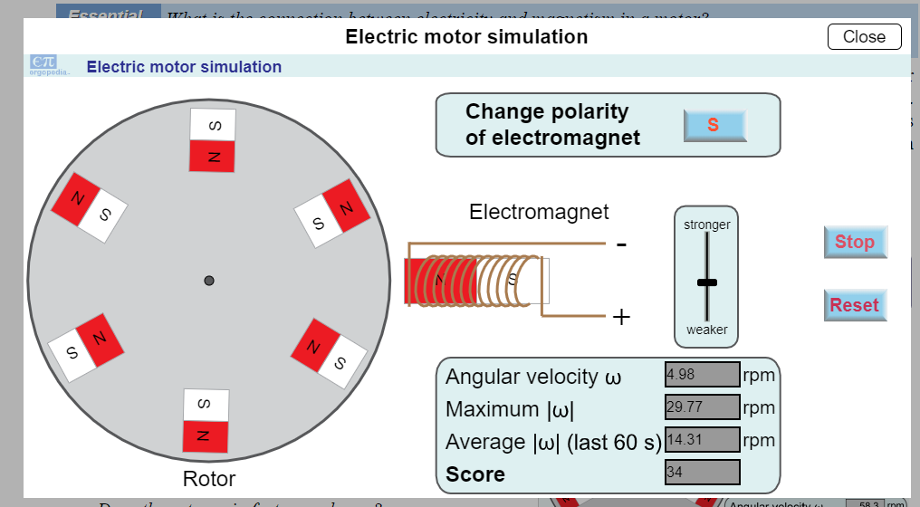

1. Record the amount of time it took you to complete this lab, and state whether any of the technology or instructions were unclear. What do you think we can do to make this activity better?

This took a little over 4 hours to watch all the videos and be able to answer all the problems.

Question 14 was interesting, I liked that it was interactive a sort of game was made from the question.

On the other hand, signing up for the website in question 13 was unnecessary.